Autonomous mobile mapping with a rotating lidar and UAV
Heikki Hyyti, Linnea Blåfield, Matias Mäki-Leppilampi, Heikki Kettunen, Harri Kaartinen
Finnish Geospatial Research Institute FGI has developed a rotating lidar platform which enables accurate three-dimensional point cloud collection. In the platform, the Riegl miniVUX-1UAV sensor is mounted on a continuously rotating, tilted structure to enable scanning of 360° x 80° field of view around the sensor (Figure 1). The rotation motion enables the sensor to measure dense range observations to objects near and far in almost all directions around the sensor. When the position and orientation of the sensor is known at all times with good enough accuracy, the point cloud accumulated during the operation can cover all static objects from all viewed directions. The developed sensor can form an accurate point cloud model from also complex natural environments such as forest, river banks, or bushes. The sensor is to be mounted on an unmanned surface vehicle, Otter by Maritime Robotics to measure the fresh water environment above the surface. This point cloud is then complemented with autonomous UAV photogrammetry to map under water areas. Using Structure-from-Motion, seamless Digital Elevation Model is created and then refined using refraction correction or Lyzengas approach. These mapping approaches provide accurate models of the river environment in three dimensions, both above and under water. These models can later be used in morphodynamic and hydraulic modelling, change detection and much more.
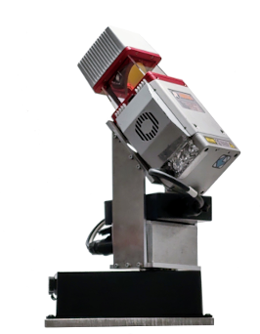
Figure 1: The FGI’s rotating lidar platform

